Living Well with MS Module 4

Stress

Here we are at our fourth and final module. We hope you’ve found this journey helpful and that it’s given you time to focus on yourself and how to live well.

You’ll now be thinking more about what living well means for you, and the ways in which you self-manage. You’ll have reflected on the best ways for you to manage your fatigue. And you’ll have considered the balance you have in your life and what’s working well for you.

This module is dedicated to thinking about stress, what causes it, and ways to get it under control. We hope this will give you an opportunity to reflect on what causes you stress and ways to manage or minimise it. We look forward to hearing about the ways you manage stress currently and hope we can help you to discover some new ones.

In this module you will:

- learn about what causes you stress and how you react to it
- reflect on what positive strategies you use to manage stress and learn new ones to try
- share and hear ideas from others about how they manage stress
- experience first-hand a relaxation exercise during the virtual chat
- review your personal goals and share experiences of working towards them

This module should take you around 15 to 20 minutes to complete.

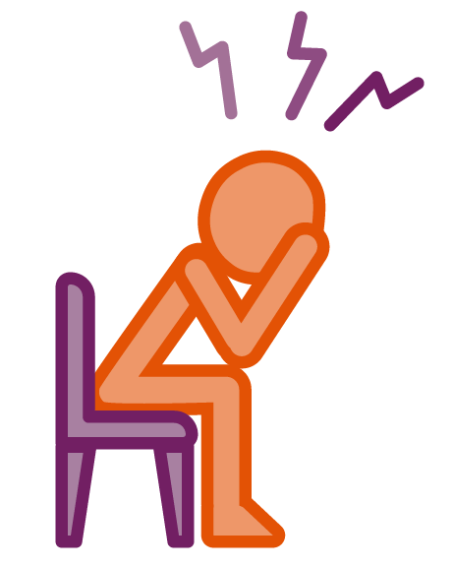
What is stress?

Although stress can be unpleasant, it’s an entirely natural experience that we all experience at some point in our lives.

It can make us perform better, for example if we’re about to run a race. But it can also have a hugely negative impact on us if the feelings of stress become out of control, prolonged or intense.

Being diagnosed with MS can be a very stressful experience. There are many unknowns and life may feel very stressful at this point. When stress becomes uncomfortable it can affect your ability to function and manage.

Although we can’t ever get rid of it completely, the good news is that we can learn how to control and manage our response to it.

When stressed we can experience many different physical, mental and emotional feelings.

Can you identify with any of these?
Please highlight or add your own.

Emotions fluctuate fluctuate
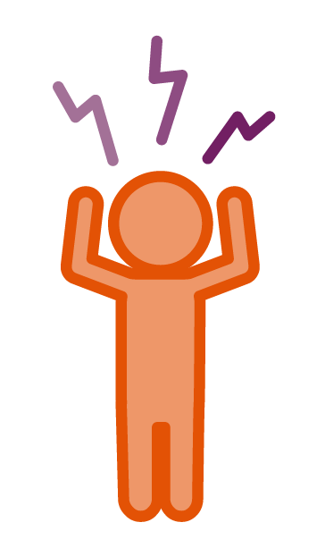
Heart racing
Poor appetite

Palms sweating
Feeling tension in muscles

Headaches

Low mood
Rapid breathing

Intrusive or negative thoughts
Butterflies in stomach

Watch this video of Craig talking about his experience of stress and how it impacts him and his MS.

Dealing with stress

You’ll have already found ways to manage or cope with these feelings when they arise. The fact that you continue to move forward is testament to that.
It can be helpful to reflect on and acknowledge the things you know help manage stress. It’s easy to forget these when we are in the middle of a stressful situation.

Sharing these in the virtual chat will help us to identify new or alternative ways to cope.

You can read more about the effects of stress and ways to manage it on our website.

There are also some great top tips in this blog for things to try which may help bust stress.

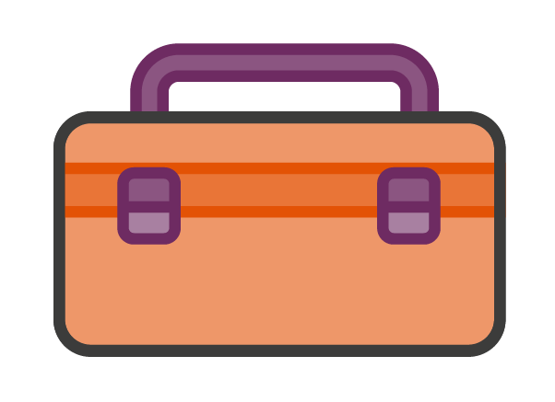
Wellness toolbox

What do you do currently that helps to relieve
or manage your stress levels?

Jot down your coping strategies in your toolbox.

- We’ll invite you to share this during the virtual chat.
Sleep

When stress is high or things are troubling us it can impact our sleep. There are of course many other things that impact sleep as well. These include:

Lifestyle choices
Temperature
Pain
Spasms
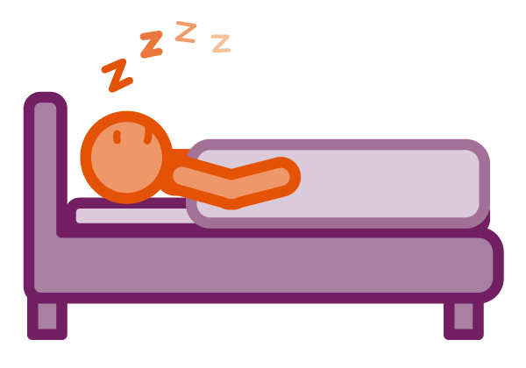
Bad habits
Bladder issues

Worries and concerns

Noise

Would you add anything to the above?

How do you feel when you’ve had a good sleep?

Sleep is essential for our health and wellbeing. Disruptions to sleep, lack of sleep or poor sleep routines can have a huge impact on our health.

It can impact:

- weight
- concentration
- mood
- energy levels
- our immune system
- work and family life
- feeling able to cope

And lots more…

What’s your current sleep routine?

Do you have issues with your sleep? If so, do you know what’s
causing them?

What have you found that helps?

The good news is that there are steps we can take to get better sleep. Nothing is a miracle cure, but if we start to make small changes we can work our way to better sleep.

Here are some things you might wish to try.

Plan how you go to sleep
- bad sleep routines can be broken but it takes work
- think about what your current routine is
- can you adjust things gradually to make this work better and aid sleep?

Winding down
Having a routine that allows you to wind down prior to bed has been shown to help with sleep. Doing something calm and relaxing such as:
- having a warm bath
- having a warm milky drink
- listening to soothing music
- reading a relaxing book
Lifestyle
- Do you have caffeine, alcohol or smoke before bed?
- Do you use gadgets in bed? E.g, phones, tablets or TV?
Putting worries aside
If there’s something bothering you it may interfere with your sleep. Why not try the following to see if it helps?
- write a list of things you are worrying about or need to do
- use a journal/diary to put the worries down on paper
- write down the worry and an action you’ll take about it – that could help reassure you that it will be dealt with and that now is time for sleep
Your environment
- Is it too hot, or too cold?
- Is your bed comfortable?
- Do you have the right bedding? Is it too warm or too light?
- Is it comfortable and dark?
- keep your room a quiet place

You might like to read this helpful blog on tips to help your sleep.

Wellness toolbox
What do you do currently that helps
you have good sleep?

Jot down your current coping strategies in
your toolbox or maybe add some new ones!

Checking in on our goals – briefly
consider this prior to the virtual chat.

How did you get on?

What went well?

What would you do differently next time?

Are you continuing with this goal or making a new goal?

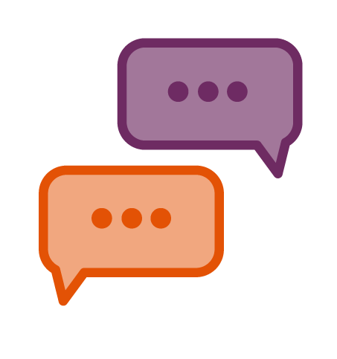
This week’s virtual chat will cover:

- quick relaxed warm up
- goal catch up
- reflections how stress can affect us and the symptoms of MS
- sharing what we do to help manage stress
- thinking about sleep

Warm up

We’ll ask you to share the following:
- If you could travel anywhere where would you
go and why? And who would you take with you?

We look forward to seeing you then!

