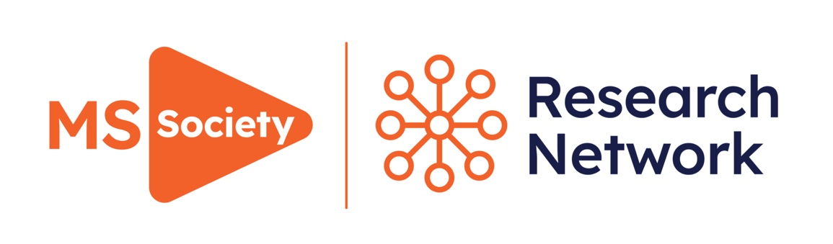
Lay summary development
Guidance and application form for researchers 2024-2025

Lay summary development
Lay summary development offers you the chance to receive input from our Research Network before you submit your funding application.

What is the Research Network?
A group of over 350 people affected by MS, either living with MS themselves or with a partner, family member or friend with a diagnosis. They’re trained to use their personal experiences of MS to improve the quality and relevance of research.

Why consult people affected by MS before submitting your lay summary?
You need to write a clear lay summary and involvement plan for your proposal. People affected by MS will review your application alongside experts in your field. If your lay summary is too brief or too complex, it’ll be difficult for them to comment on and score your application. And this will affect whether it might be funded.

Our lay summary development scheme can help you to write a high quality and accessible lay summary and public involvement plan. People affected by MS from our Research Network will give written feedback on your draft before you submit.

They can comment on:
- How well you have communicated your research proposal
- The importance of the topic to people affected by MS
- How well you have thought through and communicated your involvement plans

You don’t have to complete Lay Summary Development if you don’t want to. You can still apply without it. It’s not part of our review process but can help you to improve your lay summary.

How do I submit a request for lay summary development?
Email researchnetwork@mssociety.org.uk with your completed request form (see pages 5-7).

You must submit your completed form by the scheme closing date. This will be different depending on the award type you’re applying for. You’ll receive the feedback approximately four weeks before the funding application deadline (see table below).
Award type | Lay summary development scheme closes | When you will receive feedback on your lay summary
Catalyst Awards round 1 | 18 November 2024 | 16 December 2024
Project Awards | 18 November 2024 | 16 December 2024

What happens once I’ve submitted my request?
- Your lay summary and public involvement plan will be reviewed by 3-5 Research Network members (dependant on availability).
- All responses represent the views of the individual Research Network members and are not the official position of the MS Society.

How will this affect my chances of being awarded funding?
- The lay summary development scheme isn’t part of our funding review process. It’s a resource which allows you to improve the quality of your application before you submit.
- Research Network members who provide feedback as part of the lay summary development won’t review your application once it’s submitted.

Assessing impact
- Assessing the impact of our public involvement activities is very important to us. We may contact you after the award round deadline to find out how useful you found this scheme.
- What you tell us won’t affect your chances of receiving funding. Research Network members are always pleased to hear if their input was helpful.
- Your feedback will help us to improve this process for the next award round.

How to complete the request form

You should complete the below request form and return it, alongside any documentation that you’d like reviewed by the Research Network, to researchnetwork@mssociety.org.uk.

Section 1
Key information about you, your project and the funding you’re applying for.

Sections 2 and 3
Please answer the questions to outline your lay summary and public involvement plans. We encourage you to use Plain English when writing your lay summary. You can read about how we use plain English to be more accessible on our website. It should explain what you plan to do, and how this could benefit people affected by MS. Diagrams and analogies can really help.

Section 4
Here you can ask the Research Network members any specific questions about your research or public involvement plans. They can respond based on their personal experiences of MS.

Some examples might be:
- Are the proposed research questions important to people affected by MS?
- Are the requirements placed upon study participants – such as number and length of visits – realistic and achievable? Are the procedures too invasive or burdensome?
- Do the outcome measures capture what’s important to people affected by MS?

You can ask much more specific questions than these. And you can ask as many or as few questions as you like.

Please note, you can’t use this scheme for recruiting participants or advisory members for your research.

If you would like further support with your public involvement plans or to recruit new public representatives, please email researchnetwork@mssociety.org.uk. Or download our public involvement request form from our webpage.

Section 5
We’ve set a few standard questions for our Research Network members to answer when reviewing your lay summary and public involvement plan. The feedback from these questions can help you to improve your application before submission.

Lay summary development request form – 2024/25

Please complete the below request form, and return it with any other documentation that you’d like the Research Network to review to researchnetwork@mssociety.org.uk.

Make sure you submit these documents by the closing date of the lay summary development scheme for the award round you’re applying to (see table on page 2).

- Application details

Lead applicant’s name:
Institution:
Lay project title:
Does this project involve animals? Yes / No
Which funding award are you applying for?

- Lay Summary

What is the aim of the project? How will it benefit people affected by MS? (300 words max.)

What is the reason for this study? (300 words max.)

How will this project be carried out? (300 words max.)

Where could your research findings lead next? (300 words max.)

How will you share your results? (300 words max.)

- Involvement of people affected by MS

How have people affected by MS been involved so far in the planning and development of this project and how has this affected the development of the project so far? (300 words max.)

How do you intend to involve people affected by MS in the ongoing development of the project? (300 words max.)

- Project specific questions from the applicant

a)

b)

c)

d)

--- --- --- --- --- --- --- --- --- --- --- --- --- --- --- --- --- ---

- Standard questions for the Research Network

How would you rate the lay summary?
☐ Excellent
☐ Good
☐ Acceptable
☐ Poor

Does the lay summary cover everything you want to know about the research project?

Was the language used clear and understandable, including any scientific terms and jargon being well explained? If not, which terms need explanation (please feel free to highlight)?

Is it clear what impact the research could have on people living with MS?

Have the plans for sharing the research findings considered appropriate ways to communicate with people affected by MS?

Do you feel the public involvement plans will lead to meaningful involvement throughout the research project? Do you have any ideas or suggestions on this?

Are there any other ways in which the lay summary could be improved?

We’re the MS Society.
Our community is here for
you through the highs, lows
and everything in between.
We understand what life’s
like with MS.
Together, we are strong
enough to stop MS.
mssociety.org.uk

Contact us
MS National Centre 020 8438 0700
info@mssociety.org.uk
MS Helpline Freephone 0808 800 8000
(weekdays 9am-9pm)
helpline@mssociety.org.uk
Online
mssociety.org.uk
facebook.com/MSSociety
twitter.com/mssocietyuk
MS Society Scotland
0131 335 4050
msscotland@mssociety.org.uk
MS Society Northern Ireland
028 9080 2802
nireception@mssociety.org.uk
MS Society Cymru
mscymru@mssociety.org.uk

